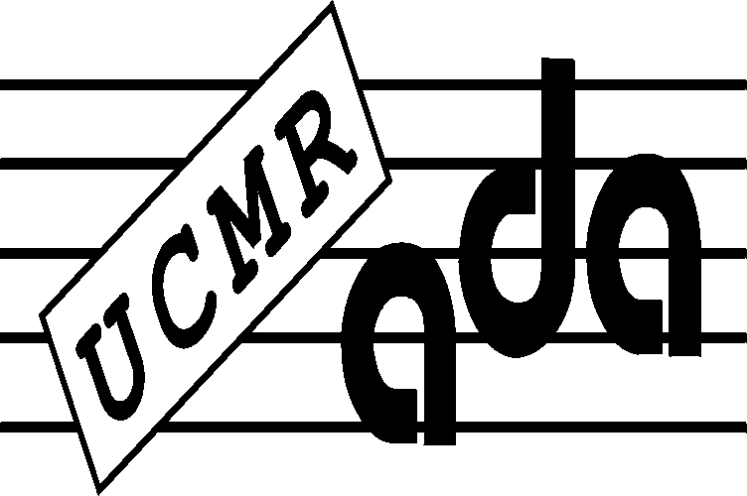
UCMR-ADA, COMPOSERS 'COPYRIGHT ASSOCIATION
Bucharest, Str. Ostasilor no.12, sect.1
goal. (021) 3167976 - fax 3165880
www.ucmr-ada.roe-mail:ada@ucmr-ada.ro

No:5/29.04.2022

Ordinary General Assembly of UCMR-ADA for the year 2021 from 28 / 29.04.2022

DECISION NO. 5 of 28 / 29.04.2022

Unique article. The Report for 2021 of the UCMR-ADA Supervisory Board is approved.

According to art. 161 para. (5) of Law no. 8/1996 on copyright and related rights, republished and art. 7.1.4 lit. g) of the UCMR-ADA Statute, the Annual Report of UCMR-ADA Supervisory Board is approved by the Ordinary General Assembly of the members of UCMR-ADA.

CJ Daniel Slevoaca

