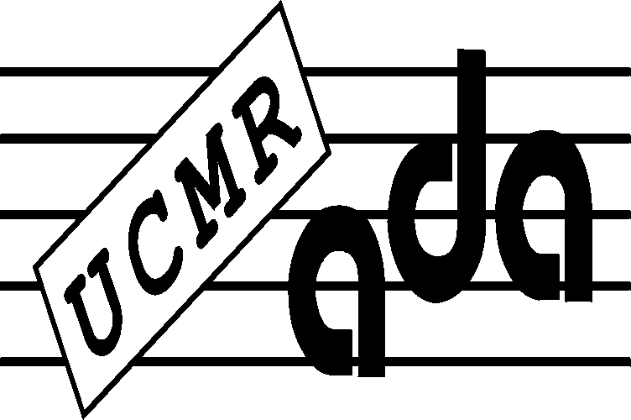
UCMR-ADA, COMPOSERS 'COPYRIGHT ASSOCIATION
Bucharest, Str. Ostasilor no.12, sect.1
goal. (021) 3167976 - fax 3165880
www.ucmr-ada.roe-mail:ada@ucmr-ada.ro

No. 8/29.04.2022

Ordinary General Assembly of UCMR-ADA for the year 2021 from 28 / 29.04.2022

DECISION NO.8 of 28 / 29.04.2022

Unique article.The Revenue and Expenditure Budget of UCMR-ADA forecast for 2022 is approved.

According to art. 7.1.4 lit. t) of the UCMR-ADA Statute The budget of revenues and expenditures foreseen for the year 2022 is subject to the approval of the General Assembly of the UCMR-ADA members.

CJ Daniel Slevoaca

